Lesson Designed by Dr. Rosen and Preet

PA Core Resources from SAS, 9–12:
Standard - 3.1.B.B1

Explain that the information passed from parents to offspring is transmitted by means of genes which are coded in DNA molecules.

Explain the basic process of DNA replication.

Describe the basic processes of transcription and translation.

Explain how crossing over, jumping genes, and deletion and duplication of genes results in genetic variation.

Explain how mutations can alter genetic information and the possible consequences on resultant cells.
Standard- 3.1.12.B6

Evaluate experimental information for relevance and adherence to science processes.

Judge that conclusions are consistent and logical with experimental conditions.

Interpret results of experimental research to predict new information, propose additional investigable questions, or advance a solution.

Communicate and defend a scientific argument.
http://www.pdesas.org/Standard/View#
NSES (USA) Content Standards, 9–12:
• NSES 1.2. Unifying Concepts and Processes: Evidence, models, and explanation
• NSES 2.1. Science as Inquiry: Abilities necessary to do scientific inquiry
• NSES 2.2. Science as Inquiry: Understanding about scientific inquiry
• NSES 6.2. Science and Technology: Understanding about science and technology
https://www.csun.edu/science/ref/curriculum/reforms/nses/nses-content-standards.pdf

https://www.csun.edu/science/ref/curriculum/reforms/nses/

Lesson Objectives: Students will…
• explain the features of NCBI interface on the internet
• know how to search for records at NCBI, both using search terms or identifiers,
or using a nucleotide sequence and BLAST
• understand the difference between the nucleotide sequence database part of GenBank and
the protein sequence part of it
• know the parts of a GenBank record and be able to switch between sequence formats
(e.g. to FASTA format)
• be able to use BLAST for local alignments of ncleotide and protein sequences
• explain how to use NCBI Primer-BLAST in order to amplify a gene for functional studies

Key Words: bioinformatics, NCBI, nucleotide, amino acid, protein, DNA,gene, genomics, proteomics, pharmacogenomics, chromosome, organism, taxonomy, GenBank, FASTA, BLAST, accession number, chromatogram, mutation, phenotype, genotype, phylogeny.

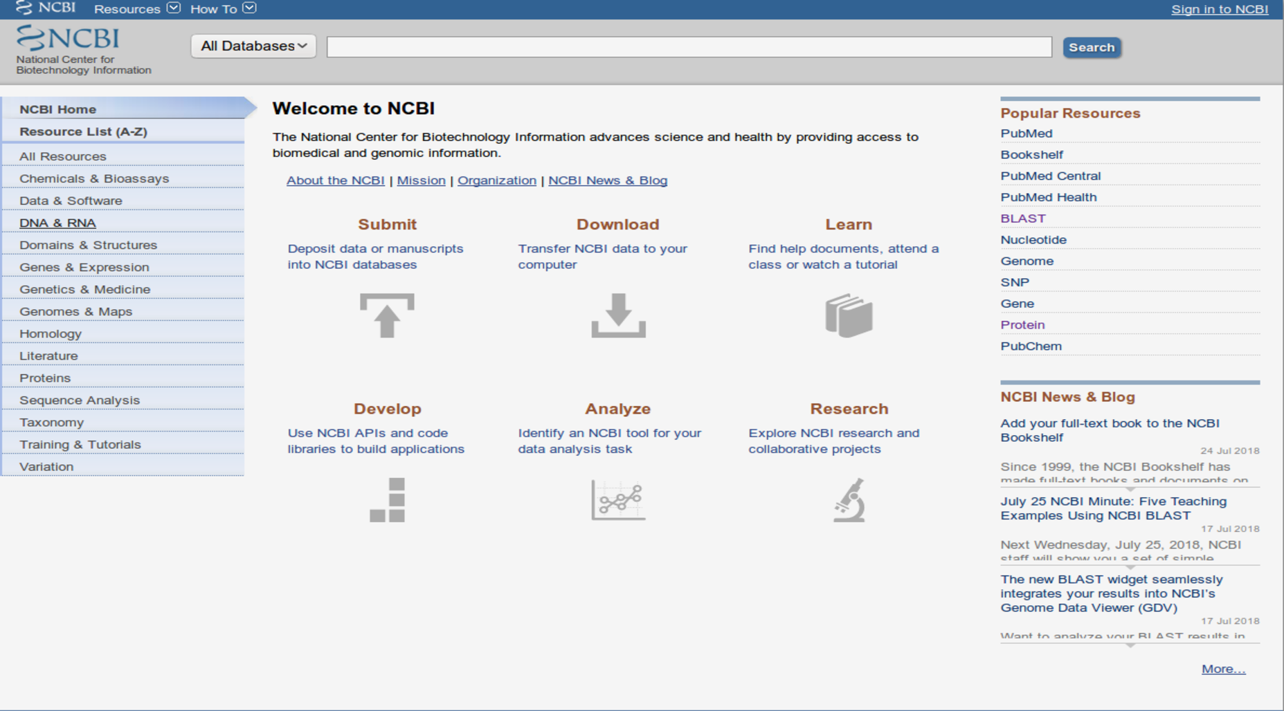
Fig1. The NCBI homepage
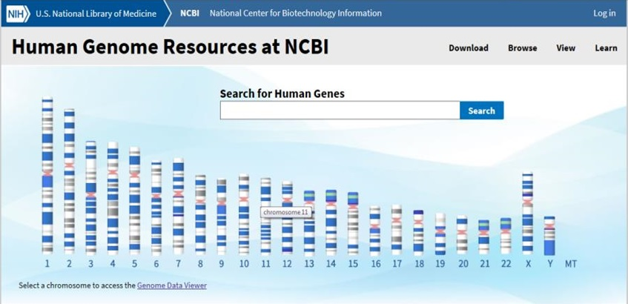
Fig2. Human Genome Resources Browser

Activity1:
Lesson Objectives: Students will…
• explain the features of NCBI interface on the internet
• know how to search for records at NCBI, both using search terms or identifiers,
or using a nucleotide sequence and BLAST
• understand the difference between the nucleotide sequence database part of GenBank and
the protein sequence part of it
• know the parts of a GenBank record and be able to switch between sequence formats
(e.g. to FASTA format)

Go to the NCBI homepage on your browser. Click on Genomes and Maps (Fig1). Click on the Human genome. You will see the map of human chromosomes (Fig2). Now type ‘TP53’ in search for human genes and look at the results for TP53. It will give you at least 20 gene hits. Click on the first entry TP53 ID: 7157 tumor protein p53 [Homo sapiens (human)] and will show you full GenBank description like shown in Fig3. Now go to the TP53 graphic display and click on GenBank. The results will look exactly like shown in Fig4.

Find out the following for TP53:
- Locus
- Accession number and Version
- Region
- Source and Organism
- Journal, References, Authors
- Features
- What is the difference between GenBank and FASTA format?
- What does the graphical display show about this gene?
- What are exons and introns?
- Five important things you learned about this gene that you would like to share with your friends.
- What is the main function of TP53 in your cells?
- What are the clinical conditions associated with TP53?
- How does TP53 play a role in preventing cancer?
- Does information about TP53 will change your eating habits?

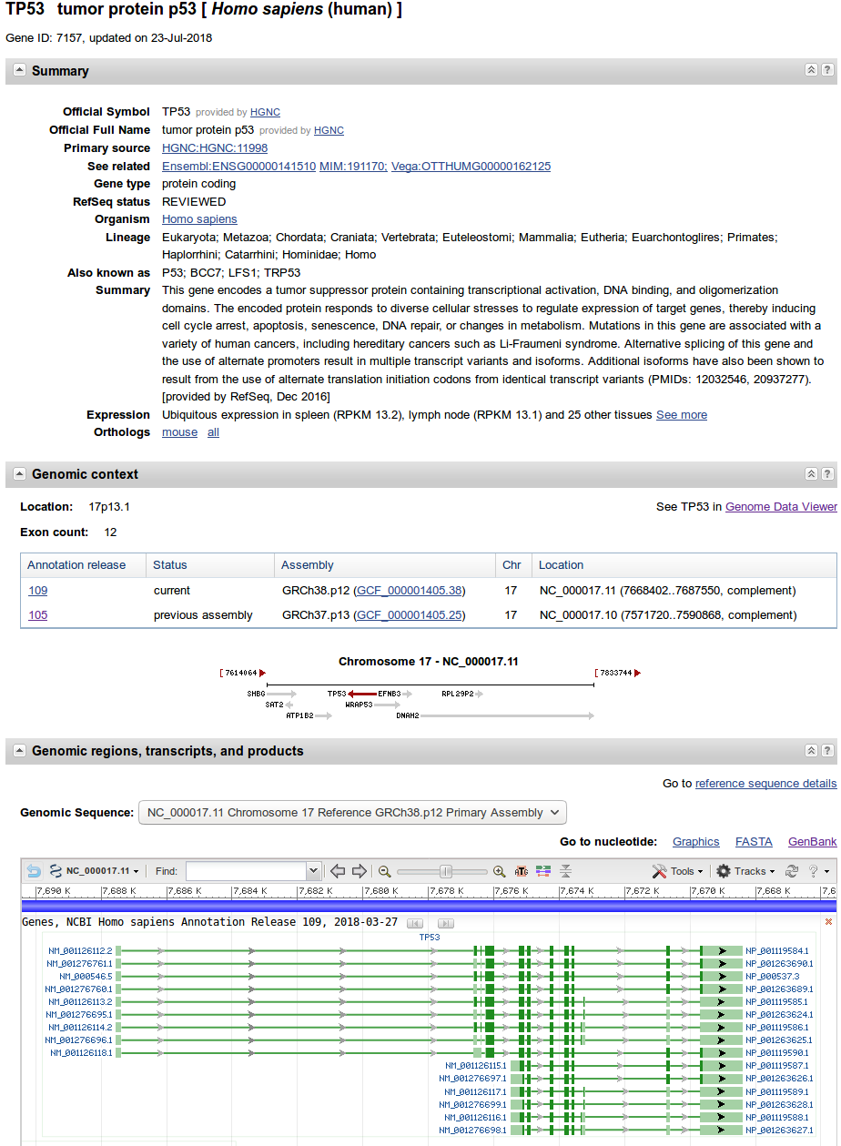
Fig 3. GenBank full report for human tumor protein p53 also known as TP53

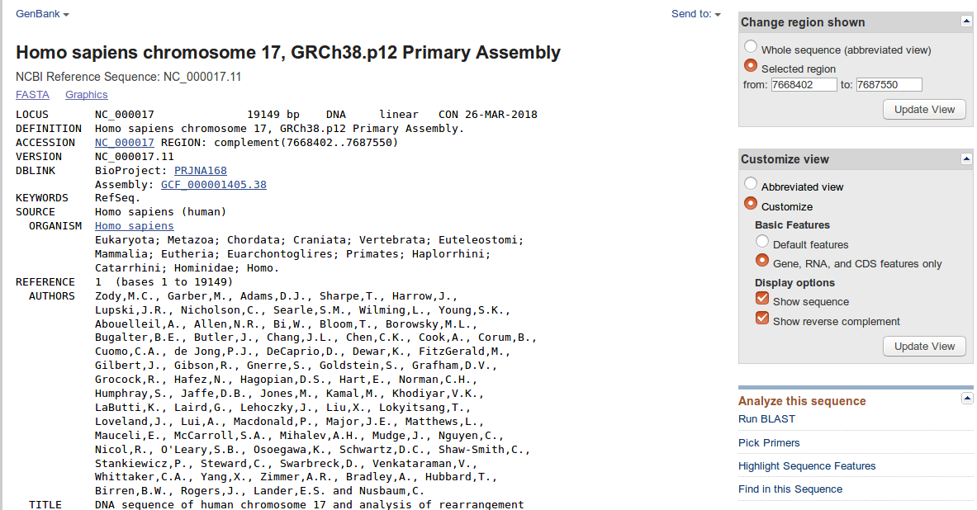

Fig4. GenBank page linked from TP53 tumor protein p53 [ Homo sapiens (human) ]
also known as nucleotide GenBank report.
Activity2:
Objectives: Students will…
• understand the difference between the nucleotide sequence database part of GenBank and
the protein sequence part of it
• know the parts of a GenBank record and be able to switch between sequence formats
(e.g. to FASTA format)
Students will be able to use BLAST for local alignments of ncleotide and protein sequences
BLAST:
BLAST is a sequence comparison algorithm that is used to search sequence databases for optimal local alignments to a query (1). Now navigate side bar on the right and has an “Analyze this sequence” click on Run BLAST. This will take you to another window showing the accession number NC_000017, do not change any parameters and just click on BLAST. On results page as shown in fig5 at the top is the job summary. The job summary shows details about the sequence that you submitted which is known as query (Query ID NC_000017.11 ) and the database searched (Database Name non redundant as ‘nr’). Next is the graphic summary.
Scroll your mouse over the colored bars.
1. What do the colored bars mean?
2. How does the color code work?
3.What is the genus and species of the top (best) hit?
4. What happens if you click on one of the entries?
5. How does TP53 match with the TP53 from other organisms.
Activity 3:
Objectives: Students will explain how to use NCBI Primer-BLAST in order to amplify a gene for functional studies
Primer-BLAST
PCR or also known as polymerase chain reaction was first developed by Kary Mullis in 1980 (2). PCR methodology is based upon on how does DNA replicate in cells? DNA polymerase is an enzyme that can make copies of DNA with precision and specificity. It is used in labs for amplifying DNA by PCR. DNA polymerase cannot process until it finds 3’-OH group, so we need to design a small fragment of size 18-25 bp of the target DNA known as primer to help DNA polymerase for its function. Primers work in pairs – forward primer and reverse primer.
Now let us see how we can use NCBI Primer-BLAST (3) for designing primers.
Go back to TP53 gene page. If you navigate under features you will find source, gene, mRNA. Look for mRNA of WRAP53 and click on "NM_001143990.1". This will take you to another window where you will find GenBank page of Homo sapiens WD repeat containing antisense to TP53 (WRAP53), transcript variant 2, mRNA, NCBI Reference Sequence: NM_001143990.1. Again under ‘Analyze this sequence’ click on Pick Primers. This will take you to Primer-BLAST page. Just choose PCR product size ‘Min’ 500 and ‘Max’ 1000. Now go to the end of the page and click on Get Primers. This will take us to results page showing the graphical view of primer pairs (Fig.5). You can use any of these primers based upon your needs in the lab.
1. How do you amplify a target DNA using the polymerase chain reaction technique?
2. Which set of primers would be best for amplification of a 800bp Target DNA Fragment by PCR?
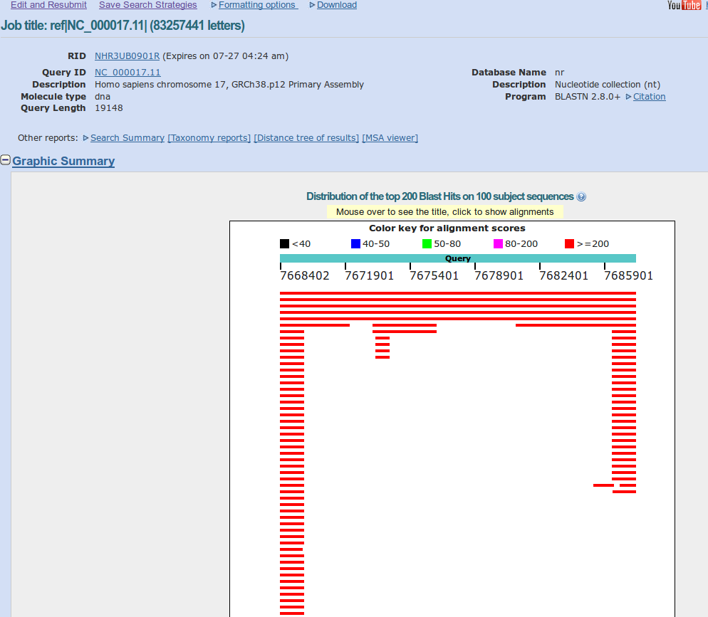

Fig5. BLAST results page
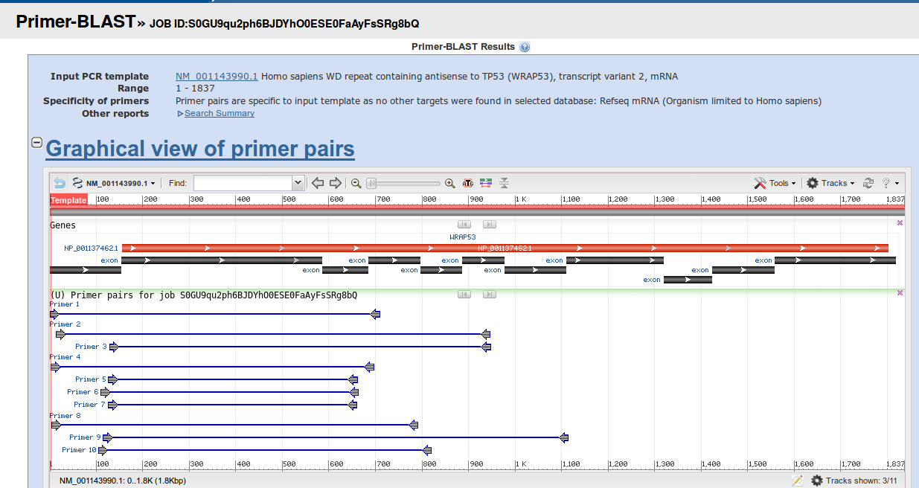

Fig6. Primer-BLAST results page

References:
1. Fassler J, Cooper P. BLAST Glossary. 2011 Jul 14. In: BLAST® Help [Internet]. Bethesda (MD): National Center for Biotechnology Information (US); 2008-.Available from: https://www.ncbi.nlm.nih.gov/books/NBK62051/
2.Saiki, R. Gelfand, D. Stoffel, S. Scharf, S. Higuchi, R. Horn, G. Mullis, K. Erlich, H. (1988). "Primer-directed enzymatic amplification of DNA with a thermostable DNA polymerase". Science. 239 (4839): 487–491.
3.Ye J, Coulouris G, Zaretskaya I, Cutcutache I, Rozen S, Madden T (2012).
Primer-BLAST: A tool to design target-specific primers for polymerase chain reaction.
BMC Bioinformatics. 13:134.

